**Food Identification and AI-Powered Calorie Calculation**

**ABSTARCT**

Measuring calories and identifying foods are essential components in managing dietary intake and encouraging healthy eating habits. These days, improvements in computer vision, machine learning, and artificial intelligence have made it easier to create intelligent systems that can recognize foods from pictures or videos and calculate the number of calories they contain. This article provides a summary of the most recent methods and tools used in calorie counting and food identification. It looks at the challenge it might be to detect a variety of foods, such as complex meals and foods from many cultures. The study also addresses the methods used to estimate the number of calories in identified food products, including nutritional makeup, components, and portion size. To improve user experience and enable thorough calorie tracking, it also looks at real-time processing capabilities, intuitive user interfaces, and connectivity with other fitness and health systems. Additionally, highlighted in the research are the potential benefits associated with these technologies for promoting personalized nutrition, educated dietary decisions, and ongoing learning for increased accuracy. All things considered, this study clarifies the developments and potential applications of food identification and calorie counting technologies, highlighting their significance in promoting better lives and overall wellbeing.

**SYSTEM ANALYSIS**

**EXISTING SYSTEM**

In the Existing System only used food items that were placed on plates and determined its calorie content based on the items' size, shape, colour, and texture, respectively. However, food in the actual world is a mixture of many kinds and substances. Calculating the number of calories in food is therefore a difficult undertaking. This model is more complex and takes more time.

**Disadvantages:**

1. Low accuracy.
2. High complexities.
3. Time Consuming compared to other techniques.

**PROPOSED SYSTEM**

In the Proposed System the CNN2D algorithm is being used in this study to identify foods and then calculate their calorie content. The program will track the user's food intake and present the results as "Available calorie in recognized food, total calorie consumed in a day, and pending calorie." An average person needs to consume 2500 calories per day. The user will be informed of the total number of calories consumed if the pending calorie value is negative.

**Advantages:**

1. High Accuracy
2. Takes less time

**MODULES DESCRIPTION:**

To implement this project, we have designed following modules

1. **Upload Food Dataset**: With the help of this module, the application will receive the dataset, read all of the pictures, and display a graph of the various food photos that have been imported.
2. **Pre-process Dataset**: will use picture processing methods including scaling to the same size, normalization, and shuffling.
3. **Split Dataset Train & Test**: divide the dataset's photos into train and test using an 80:20 ratio, with 80% of the images going toward training and 20% toward testing.
4. **Train AI on Food Dataset**: The CNN algorithm will use 80% of the training pictures to build a model, which will then be applied to 20% of the test data to determine the prediction accuracy.
5. **Food Recognition & Calorie Estimation**: With the help of this module, a test image will be uploaded, and the program will identify the type of food and calculate its calories.

**ARCHITECTURE DIAGRAM**:

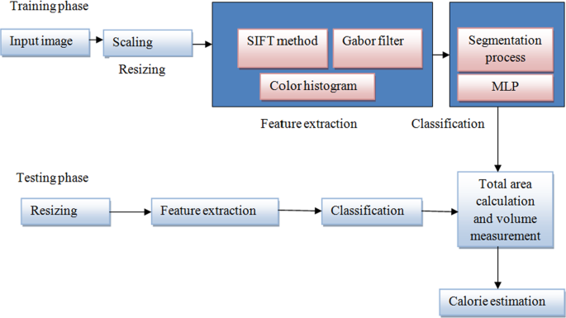

**SYSTEM REQUIREMENT:**

**HARDWARE REQUIREMENTS:**

* Processor - Intel i3(min)
* Speed - 1.1 GHz
* RAM - 4GB (min)
* Hard Disk - 500 GB

**SOFTWARE REQUIREMENTS:**

* Operating System - Windows10(min)
* Programming Language - Python (3.7.0)